CHAROTAR UNIVERSITY OF SCIENCE & TECHNOLOGY DEVANG PATEL INSTITUTE OF ADVANCE TECHNOLOGY & RESEARCH

Department of Information Technology

Subject Name: Advance Web Development Framework
Semester: V
Subject Code: ITUE301
Practical File

Practical 1 : Introduction to React and Component Architecture
Problem Definition :
- Create a React application using Vite for a student portfolio page.
- The application must include at least 4 reusable components: Header, About, Skills, and Footer.
- Each component must be independently structured and composed into a single-page layout.
- No logic or JSX should be duplicated across components.
- Props must be used to pass at least one piece of data into a minimum of 2 components.
Folder Structure :
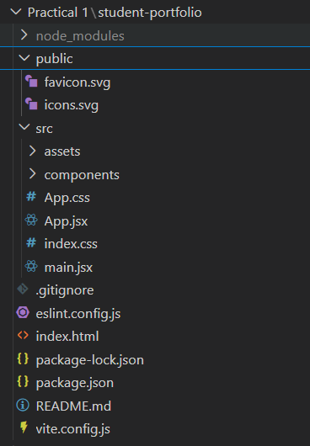

about.jsx :
function About() {
return (
<section className="section">
<h2>About Me</h2
<p>
my name is rudra and i am a student.
</p>
<div className="details">
<p><strong>College :</strong> DEPSTAR </p>
<p><strong>Subject :</strong> ITUE301 - ADVANCED WEB DEVELOPMENT FRAMEWORKS</p>
<p><strong>Semester :</strong>5th Sem</p>
<p><strong>Enrollment No :</strong> D25DIT081</p>
<p><strong>Division :</strong> 5IT </p>
</div>
</section>
);
}

export default About;

header.jsx :

function Header(props) {
return (
<section className="hero">
<h1 style={{ color: props.themeColor }}>{props.title}</h1>
<h2>{props.name}</h2>
<p>{props.role}</p>
<button>View Skills</button>
</section>
);
}

export default Header;

navbar.jsx:

function Navbar() {
return (
<nav className="navbar">
<h2 className="logo">Portfolio</h2>
<ul>
<li className="active">Home</li>
<li>About</li>
<li>Skills</li>
<li>Contact</li>
</ul>
</nav>
);
}

export default Navbar;

footer.jsx :

function Footer(props) {
return (
<section className="footer">
<h2>Contact</h2>
<p>Email : {props.email}</p>
<p>Phone : {props.phone}</p>
<p>City : {props.city}</p>
<hr />
<p>© 2026 Student Portfolio</p>
</section>
);
}

export default Footer;

skills.jsx :

function Skills(props) {
return (
<section className="section">
<h2>Technical Skills</h2>
<div className="skills">
{props.skillList.map((skill) => (
<span className="skill" key={skill}>
{skill}
</span>
))}
</div>
</section>
);
}

export default Skills;

App.css

*{
margin:0;
padding:0;
box-sizing:border-box;
}

html{
scroll-behavior:smooth;
}

body{
background:#0d0d0d;
color:#fff;
font-family:Arial, Helvetica, sans-serif;
}

.navbar{
display:flex;
justify-content:space-between;
align-items:center;
padding:20px 10%;
background:#111;
position:sticky;
top:0;
}

.logo{
font-size:22px;
}

.navbar ul{
display:flex;
list-style:none;
gap:25px;
}

.navbar li{
cursor:pointer;
color:#bdbdbd;
}

.active{
color:#fff;
font-weight:bold;
}

.hero{
height:100vh;
display:flex;
flex-direction:column;
justify-content:center;
align-items:center;
text-align:center;
padding:20px;
}

.hero h1{
font-size:55px;
}

.hero h2{
margin:15px 0 10px;
font-size:32px;
font-weight:normal;
}

.hero p,
.section p,
.footer p{
color:#bdbdbd;
line-height:1.7;
}

.hero p{
margin:20px 0 35px;
font-size:18px;
}

button{
padding:12px 30px;
border:none;
border-radius:30px;
background:#fff;
color:#000;
cursor:pointer;
}

button:hover{
background:#d8d8d8;
}

.section,
.footer{
width:80%;
margin:auto;
padding:70px 0;
border-top:1px solid #222;
}

.section h2,
.footer h2{
font-size:35px;
margin-bottom:25px;
}

.details{
margin-top:25px;
}

.skills{
display:flex;
flex-wrap:wrap;
gap:15px;
margin-top:25px;
}

.skill{
padding:12px 22px;
background:#1b1b1b;
border:1px solid #333;
border-radius:30px;
}

.footer hr{
margin:30px 0 20px;
border:none;
border-top:1px solid #333;
}

.footer-bottom{
text-align:center;
color:#888;
font-size:14px;
}

App.jsx

import "./App.css";

import Header from "./components/Header";
import About from "./components/About";
import Skills from "./components/Skills";
import Footer from "./components/Footer";
import Navbar from "./components/Navbar";

function App() {

const skills = [
"HTML",
"CSS",
"JavaScript",
"React",
"Node js",
"Vite"
];

return (
<div>
<Navbar />

<Header
title="Student Portfolio"
name="Rudra Maiyariya"
role="Computer Engineering Student"
themeColor="#ffffff"

/>

<About />

<Skills skillList={skills} />

<Footer
email="rudra@email.com"
phone="+91 1234567891"
city="Porbandar"
/>

</div>
);
}

export default App;

index.css

body{
margin:0;
}

Main.jsx:
import { StrictMode } from 'react'
import { createRoot } from 'react-dom/client'
import './index.css'
import App from './App.jsx'

createRoot(document.getElementById('root')).render(
<StrictMode>
<App />
</StrictMode>,
)

Index.html:
<!doctype html>
<html lang="en">
<head>
<meta charset="UTF-8" />
<link rel="icon" type="image/svg+xml" href="/favicon.svg" />
<meta name="viewport" content="width=device-width, initial-scale=1.0" />
<title>student-portfolio</title>
</head>
<body>
<div id="root"></div>
<script type="module" src="/src/main.jsx"></script>
</body>
</html>

Output:


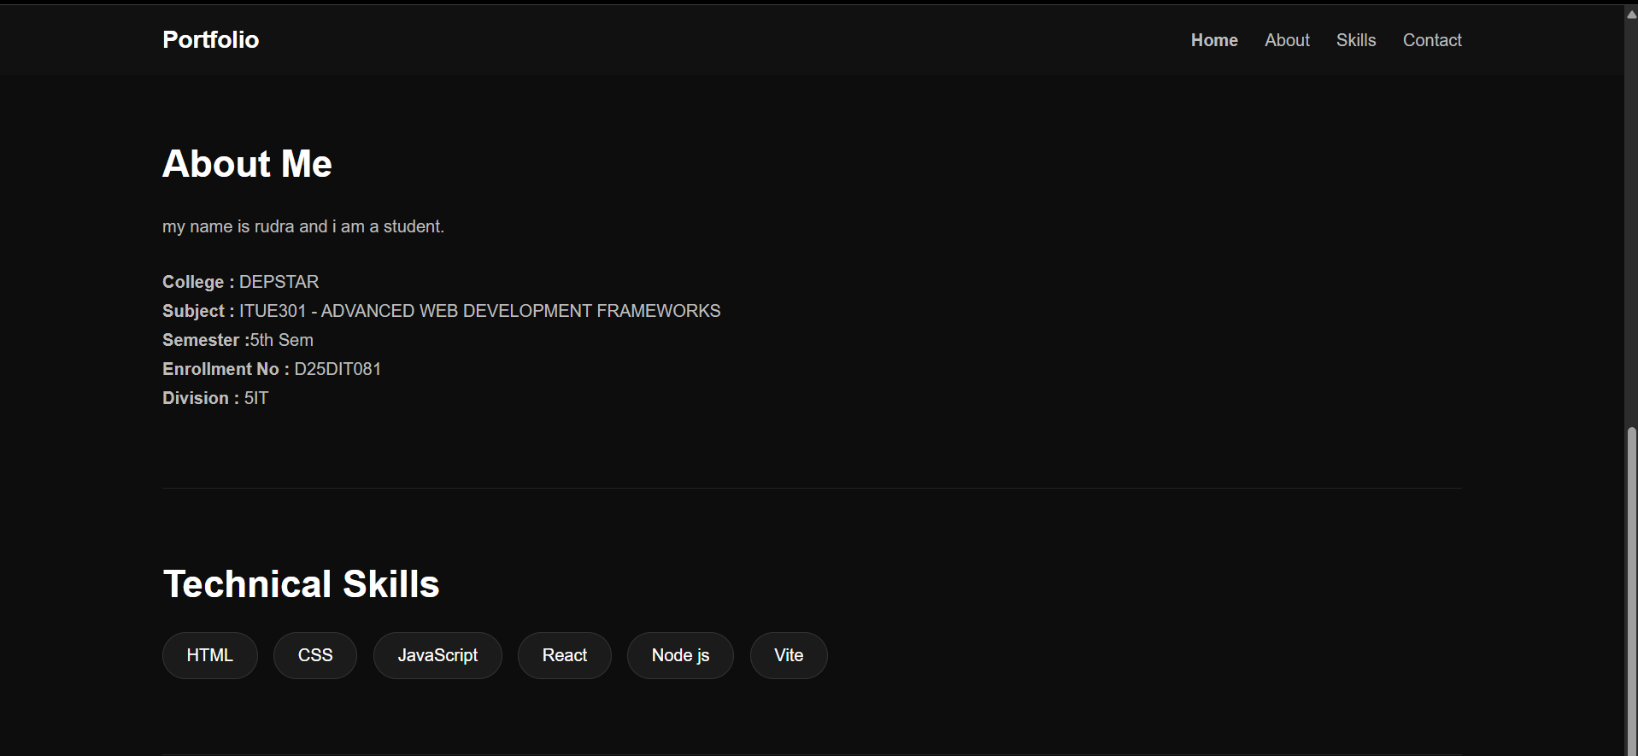
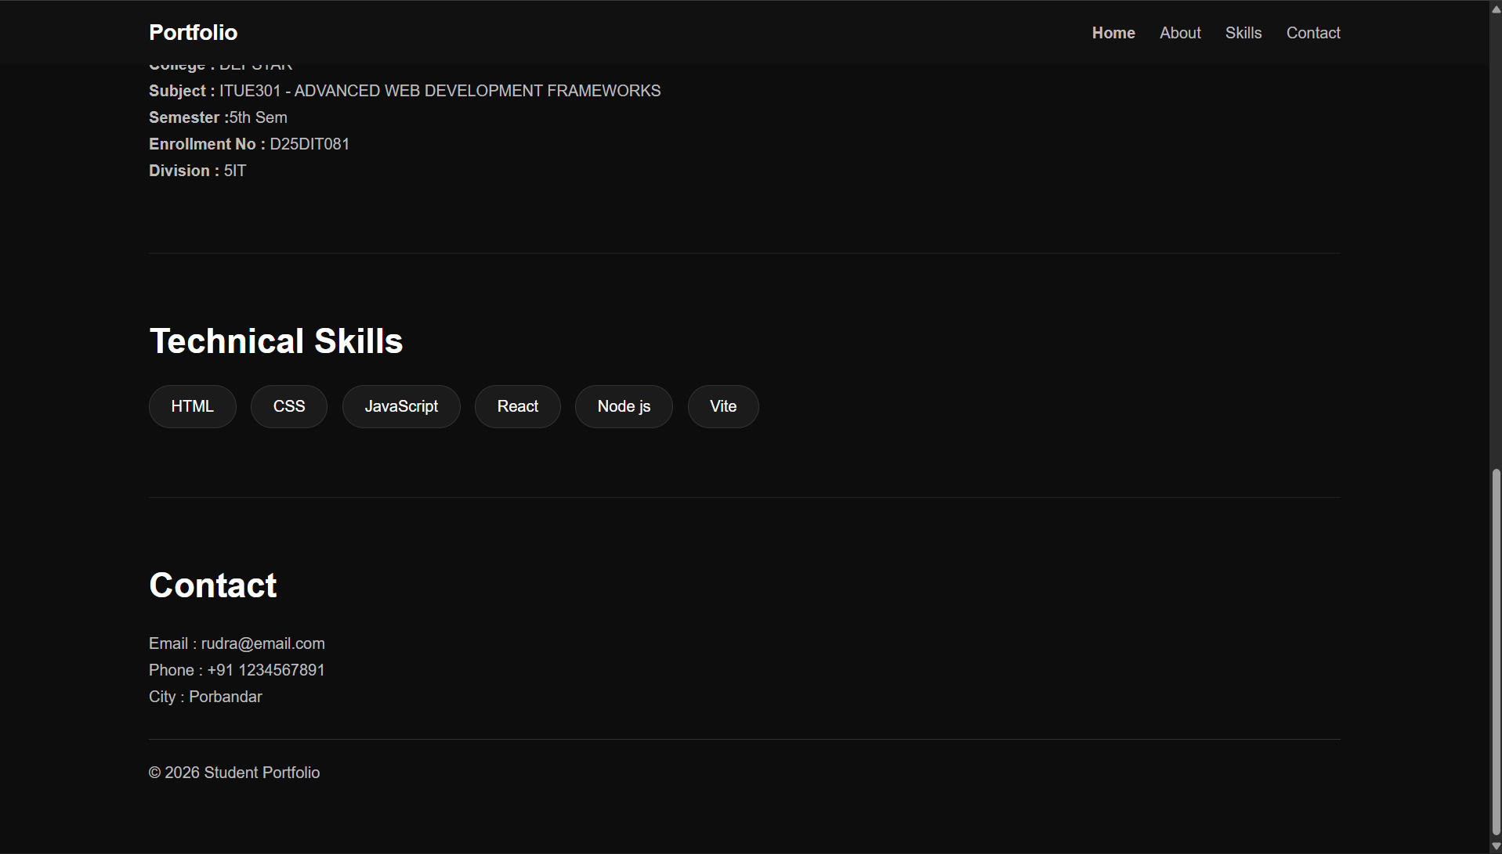

Supplementary Problems :
- Add a NavBar component that highlights the active section.

import React, { useState } from 'react';

function NavBar() {
const [active, setActive] = useState('Home');
const navItems = ['Home', 'About', 'Skills', 'Projects'];

return (
<nav style={{ display: 'flex', gap: '20px', padding: '20px', backgroundColor: '#f1f1f1' }}>
{navItems.map(item => (
<a
key={item}
href={`#${item.toLowerCase()}`}
onClick={() => setActive(item)}
style={{
fontWeight: active === item ? 'bold' : 'normal',
color: active === item ? '#0366d6' : '#333',
textDecoration: 'none'
}}
>
{item}
</a>
))}
</nav>
);
}
export default NavBar;

- Pass an array of skills as a prop to the Skills component and render them dynamically.

// Skills.jsx
import React from 'react';

function Skills({ skillsList }) {
return (
<section>
<h2>My Skills</h2>
<ul>
{skillsList.map((skill, index) => (
<li key={index}>{skill}</li>
))}
</ul>
</section>
);
}
export default Skills;

// Usage in App.jsx:
// <Skills skillsList={['HTML', 'CSS', 'JavaScript', 'React']} />

- Add a theme color prop to the Header and apply it as an inline style.\

// Header.jsx
import React from 'react';

function Header({ themeColor }) {
return (
<header style={{ backgroundColor: themeColor, padding: '20px', color: 'white' }}>
<h1>My Portfolio</h1>
</header>
);
}
export default Header;

// Usage in App.jsx:
// <Header themeColor="#282c34" />

Key Questions / Analysis :
- What is the role of each component in the overall UI structure?

Answer:Components act as independent, modular building blocks of the UI. For example, a Header handles navigation and branding, while a Skills component handles rendering data lists. This modularity makes code easier to read and maintain.

- How does React re-render when props change?

Answer:When a parent component passes new props to a child component, React automatically detects the change, compares the new virtual DOM to the old one, and efficiently re-renders only the components and DOM nodes that actually changed.

- Why is component reusability important in large-scale applications?

It prevents code duplication (DRY principle). If you have a reusable Button component, you only have to write it once. When you need to update its styling or fix a bug, you only change it in one file, and the update propagates everywhere across the large-scale app.

Practical 2 : State Management and Routing in React

Problem Definition :
• Extend the portfolio application from Practical 1 by adding React Router.
• Implement a navigation bar with at least 3 routes: Home, Projects, and Contact.
• Each route must render a distinct component without a full page reload.
• Add at least 2 useState variables used meaningfully one for toggling UI visibility and one for managing a form input on the Contact page.
• The Contact page must include a controlled input that captures and displays user input in real time.
Folder Structure:
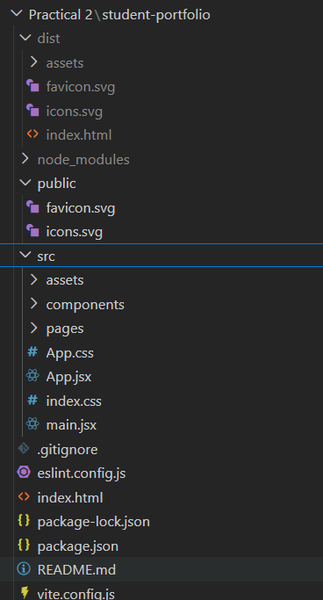

Code:
Index.html:

<!doctype html>
<html lang="en">
<head>
<meta charset="UTF-8" />
<link rel="icon" type="image/svg+xml" href="/favicon.svg" />
<meta name="viewport" content="width=device-width, initial-scale=1.0" />
<title>student-portfolio</title>
<script type="module" crossorigin src="/assets/index-wjLdS5mD.js"></script>
<link rel="stylesheet" crossorigin href="/assets/index-ClJC4mhn.css">
</head>
<body>
<div id="root"></div>
</body>
</html>

About.jsx:

function About() {

return (

<section className="section">

<h2>About Me</h2>

<p>
my name is rudra and i am a student.
</p>

<div className="details">

<p><strong>College :</strong> DEPSTAR </p>

<p><strong>Subject :</strong> ITUE301 - ADVANCED WEB DEVELOPMENT FRAMEWORKS</p>

<p><strong>Semester :</strong>5th Sem</p>

<p><strong>Enrollment No :</strong> D25DIT081</p>

<p><strong>Division :</strong> 5IT </p>

</div>

</section>

);

}

export default About;

Contact.jsx

import { useState } from "react";

function Contact() {
const [message, setMessage] = useState("");

return (
<section className="section">
<h2>Contact Page</h2>
<p>Send a message below and see real-time updates:</p>

<div className="details" style={{ marginTop: "25px" }}>
<label htmlFor="messageInput" style={{ display: "block", marginBottom: "10px", color: "#bdbdbd" }}>
Write Message:
</label>
<input
id="messageInput"
type="text"
value={message}
onChange={(e) => setMessage(e.target.value)}
placeholder="Type your message"
style={{
padding: "12px 20px",
width: "100%",
maxWidth: "450px",
borderRadius: "8px",
border: "1px solid #333",
background: "#1b1b1b",
color: "#fff",
fontSize: "16px",
outline: "none"
}}
/>

<div style={{ marginTop: "25px" }}>
<p><strong>Entered Text (Real Time):</strong></p>
<p style={{ color: "#fff", marginTop: "10px" }}>
{message || "No text entered yet..."}
</p>

<div style={{ marginTop: "15px" }}>
<p><strong>Character Count:</strong> {message.length}</p>
</div>
</div>

</div>
</section>
);
}

export default Contact;

Footer.jsx:

function Footer(props) {

return (

<section className="footer">

<h2>Contact</h2>

<p>Email : {props.email}</p>

<p>Phone : {props.phone}</p>

<p>City : {props.city}</p>

<hr />

<p>© 2026 Student Portfolio</p>

</section>

);

}

export default Footer;

Header.jsx:

function Header(props) {

return (

<section className="hero">

<h1 style={{ color: props.themeColor }}>{props.title}</h1>

<h2>{props.name}</h2>

<p>{props.role}</p>

<button>View Skills</button>

</section>

);

}

export default Header;

Home.jsx

import { useState } from "react";
import Header from "./Header";
import About from "./About";
import Skills from "./Skills";

function Home() {
const [showAbout, setShowAbout] = useState(true);

const skills = [
"HTML",
"CSS",
"JavaScript",
"React",
"Node js",
"Vite"
];

return (
<div>
<Header
title="Student Portfolio"
name="Rudra Maiyariya"
role="Computer Engineering Student"
themeColor="#ffffff"
/>

<div style={{ textAlign: "center", margin: "10px 0" }}>
<button onClick={() => setShowAbout(!showAbout)}>
{showAbout ? "Hide About Section" : "Show About Section"}
</button>
</div>

{showAbout && <About />}

<Skills skillList={skills} />
</div>
);
}

export default Home;

Navbar.jsx:

import { NavLink } from "react-router-dom";

function Navbar() {
return (
<nav className="navbar">

<h2 className="logo">Portfolio</h2>

<ul>

<li>
<NavLink to="/" className={({ isActive }) => (isActive ? "active" : "")}>
Home
</NavLink>
</li>

<li>
<NavLink to="/projects" className={({ isActive }) => (isActive ? "active" : "")}>
Projects
</NavLink>
</li>

<li>
<NavLink to="/contact" className={({ isActive }) => (isActive ? "active" : "")}>
Contact
</NavLink>
</li>

</ul>

</nav>
);
}

export default Navbar;

Project.jsx:

function Projects() {
return (
<section className="section">
<h2>My Projects</h2>
<div className="details">
<div style={{ marginBottom: "25px" }}>
<h3 style={{ fontSize: "22px", marginBottom: "8px" }}>Practical 1 - Portfolio Foundation</h3>
<p>Built the initial React portfolio application with reusable components (Header, About, Skills, Footer) and modern UI styling.</p>
</div>
<div style={{ marginBottom: "25px" }}>
<h3 style={{ fontSize: "22px", marginBottom: "8px" }}>Practical 2 - React Router & Hooks</h3>
<p>Extended the portfolio application with multi-page client-side routing using React Router and interactive state management with useState hooks.</p>
</div>
</div>
</section>
);
}

export default Projects;

Skill.jsx:

function Skills(props) {

return (

<section className="section">

<h2>Technical Skills</h2>

<div className="skills">

{props.skillList.map((skill) => (

<span className="skill" key={skill}>
{skill}
</span>

))}

</div>

</section>

);

}

export default Skills;

NotFound.jsx:

function NotFound() {
return (
<section className="section">
<h2>404 - Page Not Found</h2>
<p>The page you are looking for does not exist.</p>
</section>
);
}

export default NotFound;

App.css:

*{
margin:0;
padding:0;
box-sizing:border-box;
}

html{
scroll-behavior:smooth;
}

body{
background:#0d0d0d;
color:#fff;
font-family:Arial, Helvetica, sans-serif;
}

.navbar{
display:flex;
justify-content:space-between;
align-items:center;
padding:20px 10%;
background:#111;
position:sticky;
top:0;
}

.logo{
font-size:22px;
}

.navbar ul{
display:flex;
list-style:none;
gap:25px;
}

.navbar li{
cursor:pointer;
color:#bdbdbd;
}

.navbar a{
color:#bdbdbd;
text-decoration:none;
}

.active,
.navbar a.active{
color:#fff;
font-weight:bold;
}

.hero{
height:100vh;
display:flex;
flex-direction:column;
justify-content:center;
align-items:center;
text-align:center;
padding:20px;
}

.hero h1{
font-size:55px;
}

.hero h2{
margin:15px 0 10px;
font-size:32px;
font-weight:normal;
}

.hero p,
.section p,
.footer p{
color:#bdbdbd;
line-height:1.7;
}

.hero p{
margin:20px 0 35px;
font-size:18px;
}

button{
padding:12px 30px;
border:none;
border-radius:30px;
background:#fff;
color:#000;
cursor:pointer;
}

button:hover{
background:#d8d8d8;
}

.section,
.footer{
width:80%;
margin:auto;
padding:70px 0;
border-top:1px solid #222;
}

.section h2,
.footer h2{
font-size:35px;
margin-bottom:25px;
}

.details{
margin-top:25px;
}

.skills{
display:flex;
flex-wrap:wrap;
gap:15px;
margin-top:25px;
}

.skill{
padding:12px 22px;
background:#1b1b1b;
border:1px solid #333;
border-radius:30px;
}

.footer hr{
margin:30px 0 20px;
border:none;
border-top:1px solid #333;
}

.footer-bottom{
text-align:center;
color:#888;
font-size:14px;
}

App.jsx
import { BrowserRouter, Routes, Route } from "react-router-dom";
import "./App.css";

import Navbar from "./components/Navbar";
import Footer from "./components/Footer";
import Home from "./components/Home";
import Projects from "./components/Projects";
import Contact from "./components/Contact";
import NotFound from "./pages/NotFound";

function App() {
return (
<BrowserRouter>
<div>
<Navbar />

<Routes>
<Route path="/" element={<Home />} />
<Route path="/projects" element={<Projects />} />
<Route path="/contact" element={<Contact />} />
</Routes>

<Footer
email="rudra@email.com"
phone="+91 1234567891"
city="Porbandar"
/>
</div>
</BrowserRouter>
);
}

export default App;
Index.css:
body{
margin:0;
}
Main.jsx:

import { StrictMode } from 'react'
import { createRoot } from 'react-dom/client'
import './index.css'
import App from './App.jsx'

createRoot(document.getElementById('root')).render(
<StrictMode>
<App />
</StrictMode>,
)

Output:


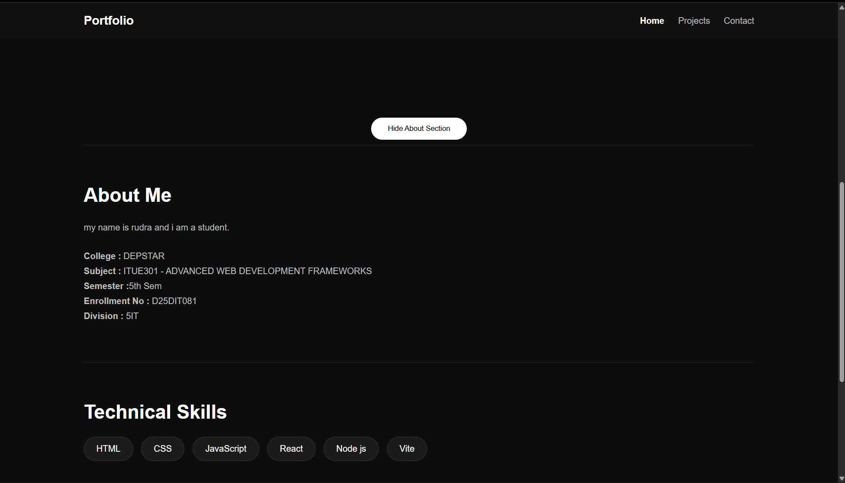

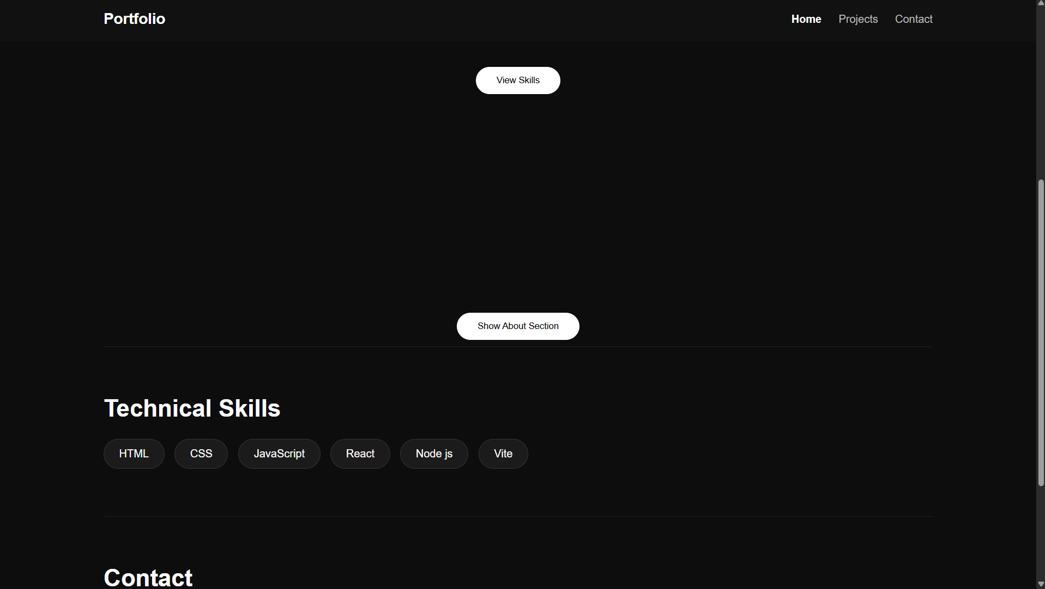

Project:

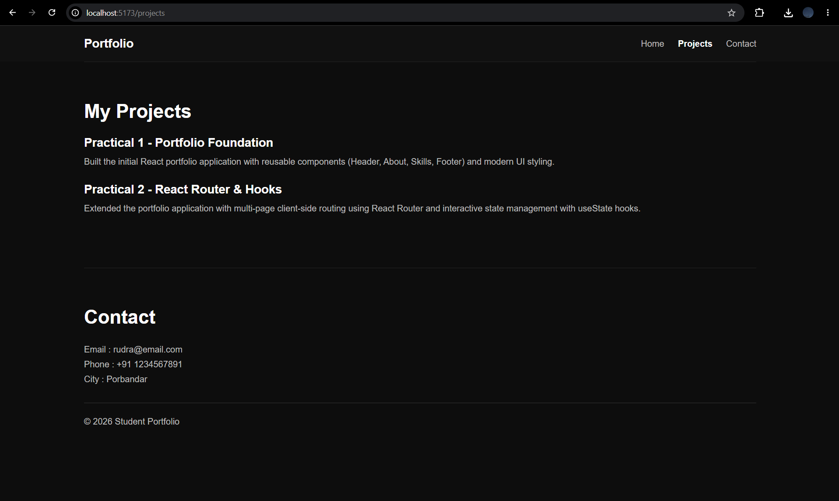

Contact:
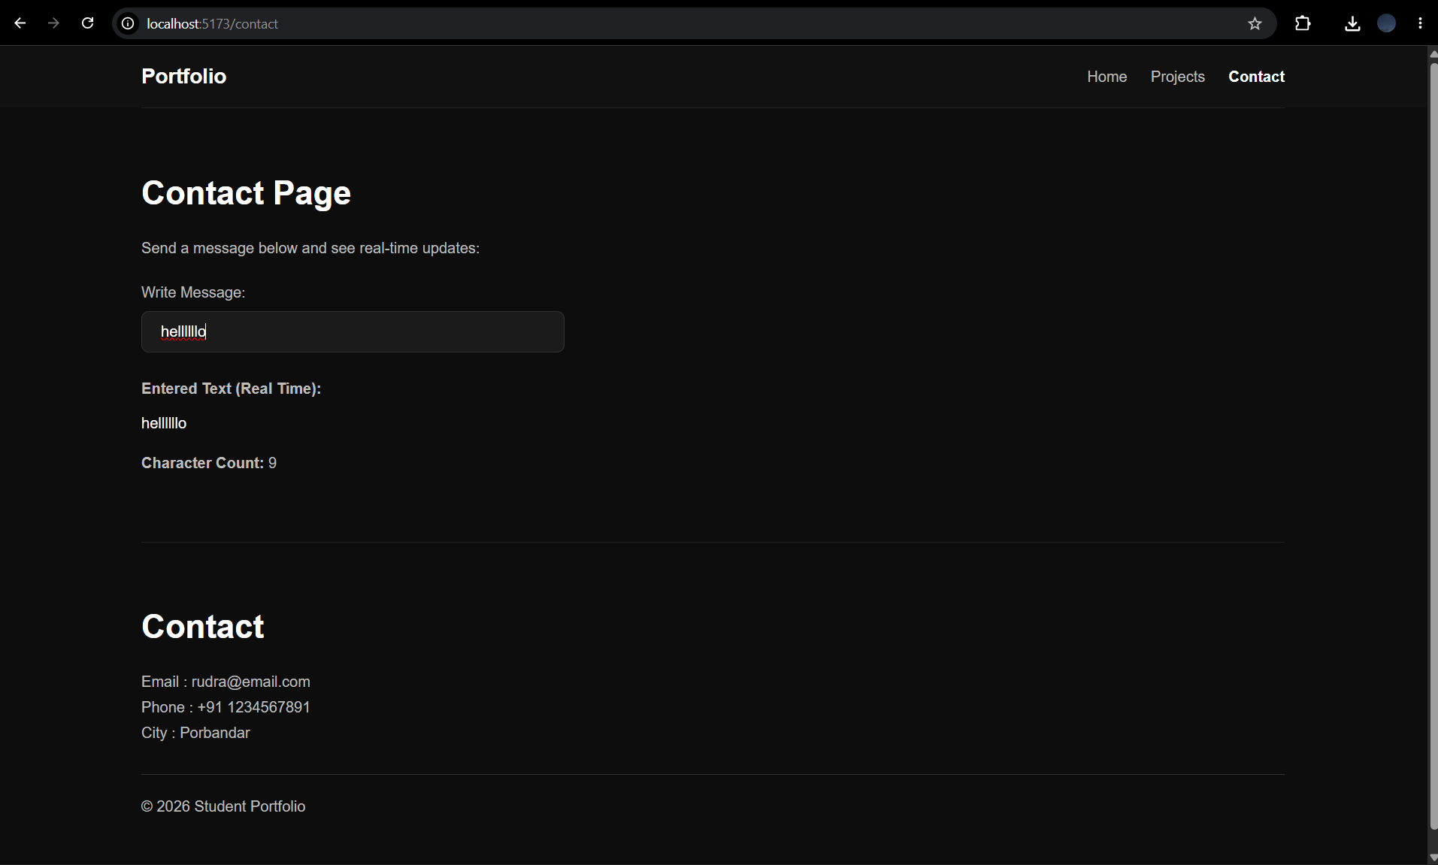

Supplementary Problems :
• Add a 404 Not Found route that renders a custom error component for unknown paths.

NotFound.jsx:
import React from 'react';
import { Link } from 'react-router-dom';

function NotFound() {
return (
<div style={{ textAlign: 'center', padding: '50px' }}>
<h2>404 - Page Not Found</h2>
<p>Oops! The page you are looking for does not exist.</p>
<Link to="/" style={{ color: 'blue', textDecoration: 'underline' }}>Go back to Home</Link>
</div>
);
}
export default NotFound;

App.jsx:
<Route path="*" element={<NotFound />} />

• Implement a dark/light mode toggle using useState that applies a CSS class to the root element.

App.jsx:
import React, { useState, useEffect } from 'react';

function App() {
const [isDarkMode, setIsDarkMode] = useState(false);

useEffect(() => {
// Toggles a CSS class on the root body element
if (isDarkMode) {
document.body.classList.add('dark-mode');
} else {
document.body.classList.remove('dark-mode');
}
}, [isDarkMode]);

return (
<div>
<button onClick={() => setIsDarkMode(!isDarkMode)}>
Switch to {isDarkMode ? 'Light' : 'Dark'} Mode
</button>
{/* Rest of the app components */}
</div>
);
}

• Store the contact form input in state and display a live character count below the input.

Contact.jsx:
import React, { useState } from 'react';

function Contact() {
const [message, setMessage] = useState('');

return (
<section>
<h2>Contact Me</h2>
<textarea
value={message}
onChange={(e) => setMessage(e.target.value)}
placeholder="Type your message..."
rows="5"
style={{ width: '100%' }}
/>
{/* Live character count display */}
<p style={{ color: '#555', fontSize: '14px' }}>
Character count: {message.length}
</p>
</section>
);
}
export default Contact;

Key Questions / Analysis :

• What is the role of each component in the overall UI structure?
Answer:In a routed application, components serve as distinct pages (e.g., Home.jsx, Contact.jsx) or shared layout shells (Navbar.jsx).

• How does React re-render when props change?
Answer:React reacts to prop and state changes. Changing the active route passes new state down the tree, causing React to unmount the old page component and mount the new one without reloading the browser.

• Why is component reusability important in large-scale applications?
Answer:In a multi-page app, you want consistent styling and behavior (like the same Navigation or Footer on every route). Reusing components guarantees this consistency and speeds up development.

Practical 3 : API Integration and Data Rendering in React

Problem Definition :
• Integrate a public REST API (e.g., GitHub API) into the portfolio application to fetch and display a list of repositories dynamically.
• Use the Projects page built in Practical 2 as the integration point.
• Implement a loading spinner component shown while the request is in progress.
• Implement an error message component shown if the API call fails.
• Render at least the repository name and URL for each item returned.

Folder Structure:

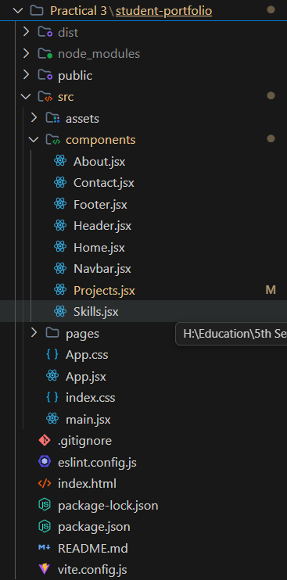
Code:
About.jsx:
function About() {

return (

<section className="section">

<h2>About Me</h2>

<p>
my name is rudra and i am a student.
</p>

<div className="details">

<p><strong>College :</strong> DEPSTAR </p>

<p><strong>Subject :</strong> ITUE301 - ADVANCED WEB DEVELOPMENT FRAMEWORKS</p>

<p><strong>Semester :</strong>5th Sem</p>

<p><strong>Enrollment No :</strong> D25DIT081</p>

<p><strong>Division :</strong> 5IT </p>

</div>

</section>

);

}

export default About;

Contact.jsx:

import { useState } from "react";

function Contact() {
const [message, setMessage] = useState("");

return (
<section className="section">
<h2>Contact Page</h2>
<p>Send a message below and see real-time updates:</p>

<div className="details" style={{ marginTop: "25px" }}>
<label htmlFor="messageInput" style={{ display: "block", marginBottom: "10px", color: "#bdbdbd" }}>
Write Message:
</label>
<input
id="messageInput"
type="text"
value={message}
onChange={(e) => setMessage(e.target.value)}
placeholder="Type your message"
style={{
padding: "12px 20px",
width: "100%",
maxWidth: "450px",
borderRadius: "8px",
border: "1px solid #333",
background: "#1b1b1b",
color: "#fff",
fontSize: "16px",
outline: "none"
}}
/>

<div style={{ marginTop: "25px" }}>
<p><strong>Entered Text (Real Time):</strong></p>
<p style={{ color: "#fff", marginTop: "10px" }}>
{message || "No text entered yet..."}
</p>

<div style={{ marginTop: "15px" }}>
<p><strong>Character Count:</strong> {message.length}</p>
</div>
</div>

</div>
</section>
);
}

export default Contact;

Footer.jsx:

function Footer(props) {

return (

<section className="footer">

<h2>Contact</h2>

<p>Email : {props.email}</p>

<p>Phone : {props.phone}</p>

<p>City : {props.city}</p>

<hr />

<p>© 2026 Student Portfolio</p>

</section>

);

}

export default Footer;

Header.jsx:

function Header(props) {

return (

<section className="hero">

<h1 style={{ color: props.themeColor }}>{props.title}</h1>

<h2>{props.name}</h2>

<p>{props.role}</p>

<button>View Skills</button>

</section>

);

}

export default Header;

Home.jsx:

import { useState } from "react";
import Header from "./Header";
import About from "./About";
import Skills from "./Skills";

function Home() {
const [showAbout, setShowAbout] = useState(true);

const skills = [
"HTML",
"CSS",
"JavaScript",
"React",
"Node js",
"Vite"
];

return (
<div>
<Header
title="Student Portfolio"
name="Rudra Maiyariya"
role="Computer Engineering Student"
themeColor="#ffffff"
/>

<div style={{ textAlign: "center", margin: "10px 0" }}>
<button onClick={() => setShowAbout(!showAbout)}>
{showAbout ? "Hide About Section" : "Show About Section"}
</button>
</div>

{showAbout && <About />}

<Skills skillList={skills} />
</div>
);
}

export default Home;

Navbar.jsx:

import { NavLink } from "react-router-dom";

function Navbar() {
return (
<nav className="navbar">

<h2 className="logo">Portfolio</h2>

<ul>

<li>
<NavLink to="/" className={({ isActive }) => (isActive ? "active" : "")}>
Home
</NavLink>
</li>

<li>
<NavLink to="/projects" className={({ isActive }) => (isActive ? "active" : "")}>
Projects
</NavLink>
</li>

<li>
<NavLink to="/contact" className={({ isActive }) => (isActive ? "active" : "")}>
Contact
</NavLink>
</li>

</ul>

</nav>
);
}

export default Navbar;

Project.jsx:

import React, { useState, useEffect } from 'react';

const Spinner = () => (
<div style={{ textAlign: 'center', padding: '20px' }}>
<div style={{
display: 'inline-block',
width: '40px',
height: '40px',
border: '4px solid rgba(0,0,0,0.1)',
borderRadius: '50%',
borderTopColor: '#3498db',
animation: 'spin 1s ease-in-out infinite'
}}></div>
<style>
{`
@keyframes spin {
to { transform: rotate(360deg); }
}
`}
</style>
<p>Loading repositories...</p>
</div>
);

const ErrorMessage = ({ message }) => (
<div style={{ color: 'red', textAlign: 'center', padding: '20px', backgroundColor: '#ffeaea', borderRadius: '5px' }}>
<h3>Failed to load repositories</h3>
<p>{message}</p>
</div>
);

function Projects() {
const [repos, setRepos] = useState([]);
const [loading, setLoading] = useState(true);
const [error, setError] = useState(null);

useEffect(() => {
fetch('https://api.github.com/users/RudraMaiyariya/repos?sort=updated&per_page=3')
.then((res) => {
if (!res.ok) {
throw new Error(`Error: ${res.status} ${res.statusText}`);
}
return res.json();
})
.then((data) => setRepos(data))
.catch((err) => setError(err.message))
.finally(() => setLoading(false));
}, []);

return (
<section className="section">
<h2>My Projects</h2>

{loading && <Spinner />}
{error && <ErrorMessage message={error} />}
{!loading && !error && (
<div className="details" style={{ display: 'grid', gridTemplateColumns: 'repeat(auto-fill, minmax(300px, 1fr))', gap: '20px' }}>
{repos.map((repo) => (
<div key={repo.id} style={{
padding: "20px",
border: "1px solid #ddd",
borderRadius: "8px",
boxShadow: "0 2px 4px rgba(0,0,0,0.1)",
backgroundColor: "#fff"
}}>
<h3 style={{ fontSize: "20px", marginBottom: "10px" }}>
<a href={repo.html_url} target="_blank" rel="noopener noreferrer" style={{ textDecoration: 'none', color: '#0366d6' }}>
{repo.name}
</a>
</h3>
<p style={{ color: '#586069', fontSize: '14px', marginBottom: '15px' }}>
{repo.description || 'No description available.'}
</p>
{/*
<div style={{ display: 'flex', gap: '15px', fontSize: '12px', color: '#586069' }}>
{repo.language && <span>🟡 {repo.language}</span>}
<span>⭐ {repo.stargazers_count}</span>
</div>
*/}
</div>
))}
</div>
)}
</section>
);
}

export default Projects;

Skill.jsx:

function Skills(props) {

return (

<section className="section">

<h2>Technical Skills</h2>

<div className="skills">

{props.skillList.map((skill) => (

<span className="skill" key={skill}>
{skill}
</span>

))}

</div>

</section>

);

}

export default Skills;

NotFound.jsx:
function NotFound() {
return (
<section className="section">
<h2>404 - Page Not Found</h2>
<p>The page you are looking for does not exist.</p>
</section>
);
}

export default NotFound;

App.css:

*{
margin:0;
padding:0;
box-sizing:border-box;
}

html{
scroll-behavior:smooth;
}

body{
background:#0d0d0d;
color:#fff;
font-family:Arial, Helvetica, sans-serif;
}

.navbar{
display:flex;
justify-content:space-between;
align-items:center;
padding:20px 10%;
background:#111;
position:sticky;
top:0;
}

.logo{
font-size:22px;
}

.navbar ul{
display:flex;
list-style:none;
gap:25px;
}

.navbar li{
cursor:pointer;
color:#bdbdbd;
}

.navbar a{
color:#bdbdbd;
text-decoration:none;
}

.active,
.navbar a.active{
color:#fff;
font-weight:bold;
}

.hero{
height:100vh;
display:flex;
flex-direction:column;
justify-content:center;
align-items:center;
text-align:center;
padding:20px;
}

.hero h1{
font-size:55px;
}

.hero h2{
margin:15px 0 10px;
font-size:32px;
font-weight:normal;
}

.hero p,
.section p,
.footer p{
color:#bdbdbd;
line-height:1.7;
}

.hero p{
margin:20px 0 35px;
font-size:18px;
}

button{
padding:12px 30px;
border:none;
border-radius:30px;
background:#fff;
color:#000;
cursor:pointer;
}

button:hover{
background:#d8d8d8;
}

.section,
.footer{
width:80%;
margin:auto;
padding:70px 0;
border-top:1px solid #222;
}

.section h2,
.footer h2{
font-size:35px;
margin-bottom:25px;
}

.details{
margin-top:25px;
}

.skills{
display:flex;
flex-wrap:wrap;
gap:15px;
margin-top:25px;
}

.skill{
padding:12px 22px;
background:#1b1b1b;
border:1px solid #333;
border-radius:30px;
}

.footer hr{
margin:30px 0 20px;
border:none;
border-top:1px solid #333;
}

.footer-bottom{
text-align:center;
color:#888;
font-size:14px;
}

App.jsx:

import { BrowserRouter, Routes, Route } from "react-router-dom";
import "./App.css";

import Navbar from "./components/Navbar";
import Footer from "./components/Footer";
import Home from "./components/Home";
import Projects from "./components/Projects";
import Contact from "./components/Contact";
import NotFound from "./pages/NotFound";

function App() {
return (
<BrowserRouter>
<div>
<Navbar />

<Routes>
<Route path="/" element={<Home />} />
<Route path="/projects" element={<Projects />} />
<Route path="/contact" element={<Contact />} />
</Routes>

<Footer
email="rudra@email.com"
phone="+91 1234567891"
city="Porbandar"
/>
</div>
</BrowserRouter>
);
}

export default App;

Index.css:
body{
margin:0;
}

Main.jsx:

import { StrictMode } from 'react'
import { createRoot } from 'react-dom/client'
import './index.css'
import App from './App.jsx'

createRoot(document.getElementById('root')).render(
<StrictMode>
<App />
</StrictMode>,
)

Output: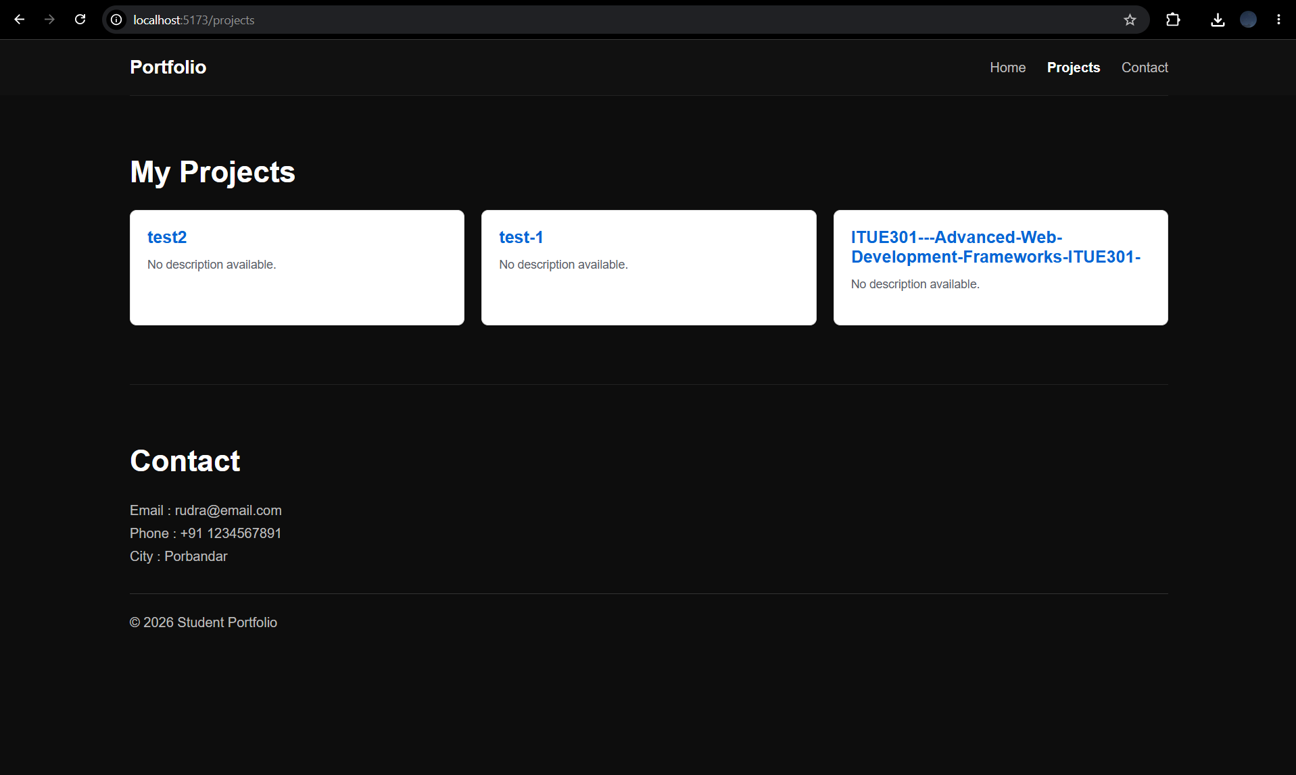

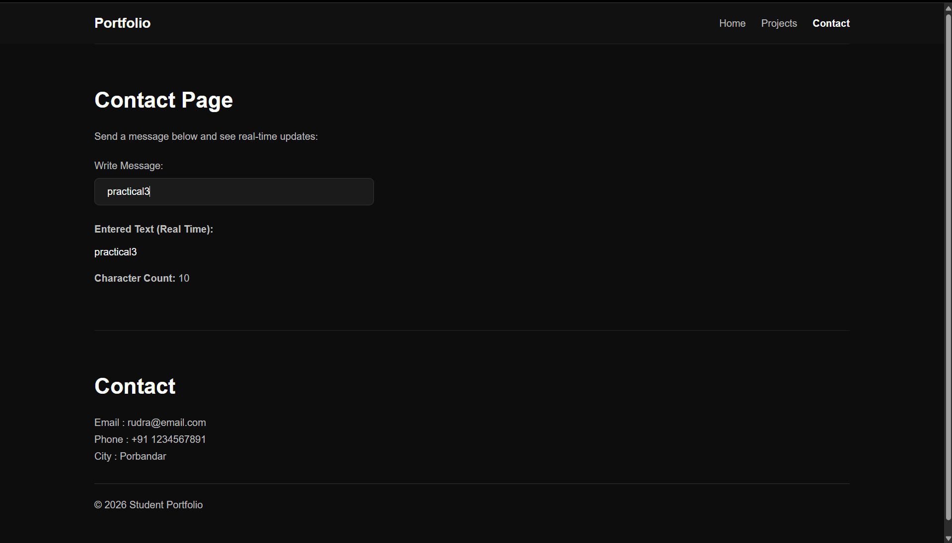

Supplementary Problems :

• Add a retry button that re-triggers the fetch when an error occurs.
• Add a search input that filters the rendered repository list by name.
• Display the repository's star count alongside its name.

import React, { useState, useEffect } from 'react';

function Projects() {
const [repos, setRepos] = useState([]);
const [loading, setLoading] = useState(true);
const [error, setError] = useState(null);

// Supplementary: Search and Retry state
const [searchTerm, setSearchTerm] = useState('');
const [retryCount, setRetryCount] = useState(0);

useEffect(() => {
setLoading(true);
setError(null);

fetch('https://api.github.com/users/RudraMaiyariya/repos')
.then((res) => {
if (!res.ok) throw new Error(`Error: ${res.status}`);
return res.json();
})
.then((data) => setRepos(data))
.catch((err) => setError(err.message))
.finally(() => setLoading(false));

// Adding retryCount to the dependency array makes it re-fetch when the retry button is clicked
}, [retryCount]);

// Supplementary: Filter the list based on the search input
const filteredRepos = repos.filter(repo =>
repo.name.toLowerCase().includes(searchTerm.toLowerCase())
);

return (
<section className="section">
<h2>My Projects</h2>

{/* Supplementary: Search Input */}
<input
type="text"
placeholder="Search repositories..."
value={searchTerm}
onChange={(e) => setSearchTerm(e.target.value)}
style={{ padding: '8px', marginBottom: '20px', width: '300px' }}
/>

{loading && <Spinner />}

{error && (
<div>
<ErrorMessage message={error} />
{/* Supplementary: Retry Button */}
<button
onClick={() => setRetryCount(prev => prev + 1)}
style={{ padding: '10px', marginTop: '10px', cursor: 'pointer' }}
>
Try Again
</button>
</div>
)}

{!loading && !error && (
<div className="details" style={{ display: 'grid', gridTemplateColumns: 'repeat(auto-fill, minmax(300px, 1fr))', gap: '20px' }}>
{filteredRepos.map((repo) => (
<div key={repo.id} style={{ padding: "20px", border: "1px solid #ddd", borderRadius: "8px" }}>
<h3><a href={repo.html_url}>{repo.name}</a></h3>

{/* Supplementary: Display star count */}
<p style={{ marginTop: '10px' }}>⭐ Stars: {repo.stargazers_count}</p>
</div>
))}
</div>
)}
</section>
);
}

export default Projects;

Key Questions / Analysis :
• Why is useEffect required to trigger a fetch on component mount instead of calling fetch directly in the component body?
Answer:Calling fetch directly in the component body runs it on every render. Because fetch is an asynchronous side effect that eventually updates state (setRepos), updating the state triggers a re-render, which would trigger another fetch, resulting in an infinite loop that crashes the app. useEffect(..., []) ensures it safely runs exactly once when the component mounts.

• What is the difference between a loading state and an error state, and why must both be handled separately?
Answer:A loading state implies a request is currently processing and unresolved. An error state implies the request has finished but failed. They represent entirely different app conditions; treating them as the same would make it impossible to know whether the user should see a loading spinner or an error message/retry button.

• How would the user experience change if loading and error states were not implemented?
Answer:Without a loading state, the user would see a blank screen or missing data while waiting for the network, making the app feel frozen or broken. Without an error state, if the network drops or the API crashes, the app would fail silently. The user would stare at an empty screen forever without knowing what went wrong.

